Title: Development of Netbanking App

The idea of the project is to develop a netbanking application that allows customers to perform online banking transactions securely and efficiently. The application will include features such as account management, transaction history, and payment options.

The following tasks need to be completed for the development of the netbanking app using the JIRA Agile Board

Epic Creation Create 5 Epic and divide each Epic into different user stories.

Creating Epic ,user story and backlog

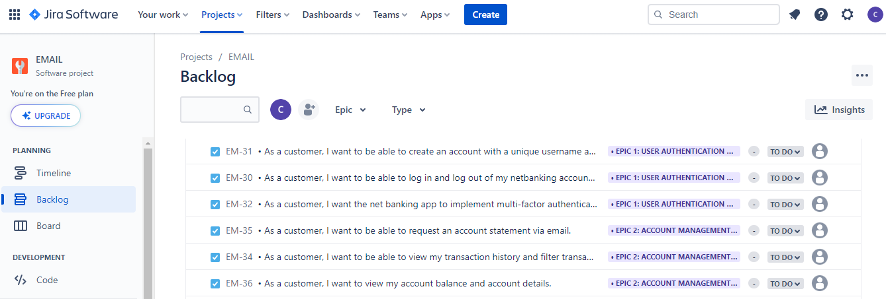

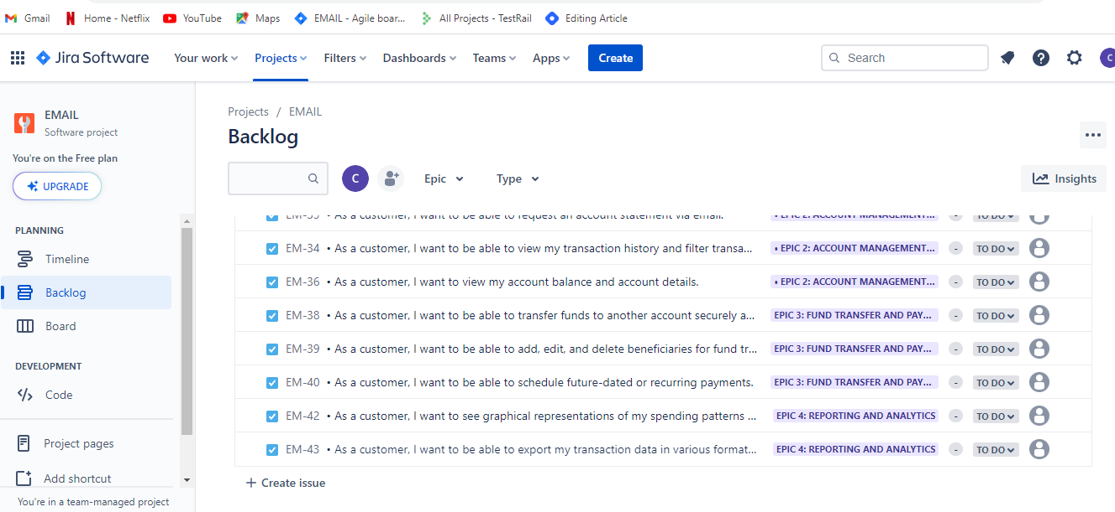

Sprint planning

Sprint -1

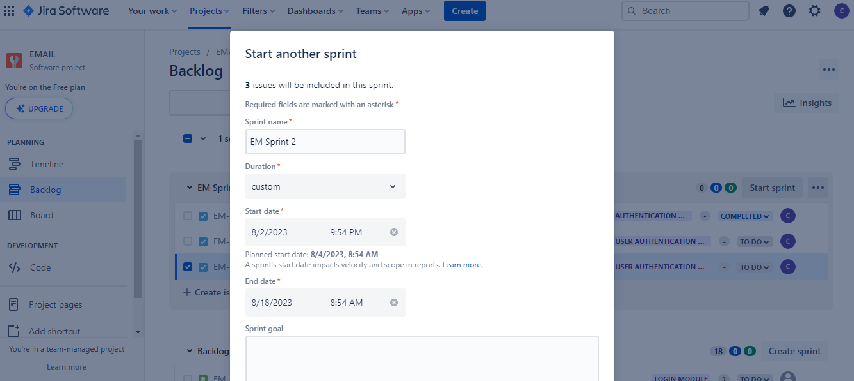

Project Management Tool: Jira

Title: Development of Netbanking App

1. Epic Creation: Create 5 Epics for the development of the Netbanking App:
   * Epic 1: User Authentication and Security
   * Epic 2: Account Management and Transaction History
   * Epic 3: Fund Transfer and Payment Options
   * Epic 4: Reporting and Analytics
   * Epic 5: User Interface and User Experience Enhancement
2. User Stories Creation: Epic 1: User Authentication and Security
   * As a customer, I want to be able to create an account with a unique username and secure password.
   * As a customer, I want to be able to log in and log out of my netbanking account securely.
   * As a customer, I want the netbanking app to implement multi-factor authentication for enhanced security.

Epic 2: Account Management and Transaction History

* + As a customer, I want to view my account balance and account details.
  + As a customer, I want to be able to view my transaction history and filter transactions by date and type.
  + As a customer, I want to be able to request an account statement via email.

Epic 3: Fund Transfer and Payment Options

* + As a customer, I want to be able to transfer funds to another account securely and easily.
  + As a customer, I want to be able to add, edit, and delete beneficiaries for fund transfers.
  + As a customer, I want to be able to schedule future-dated or recurring payments.

Epic 4: Reporting and Analytics

* + As a customer, I want to see graphical representations of my spending patterns and account activity.
  + As a customer, I want to be able to export my transaction data in various formats (CSV, PDF, etc.).

Epic 5: User Interface and User Experience Enhancement

* + As a customer, I want the netbanking app to have an intuitive and user-friendly interface.
  + As a customer, I want the app to be responsive and accessible from multiple devices.

1. Sprint Planning:

Sprint 1 (2 weeks):

* + Epic 1: User Authentication and Security
  + Epic 2: Account Management and Transaction History

Sprint 2 (2 weeks):

* + Epic 3: Fund Transfer and Payment Options
  + Epic 4: Reporting and Analytics

Sprint 3 (2 weeks):

* + Epic 5: User Interface and User Experience Enhancement